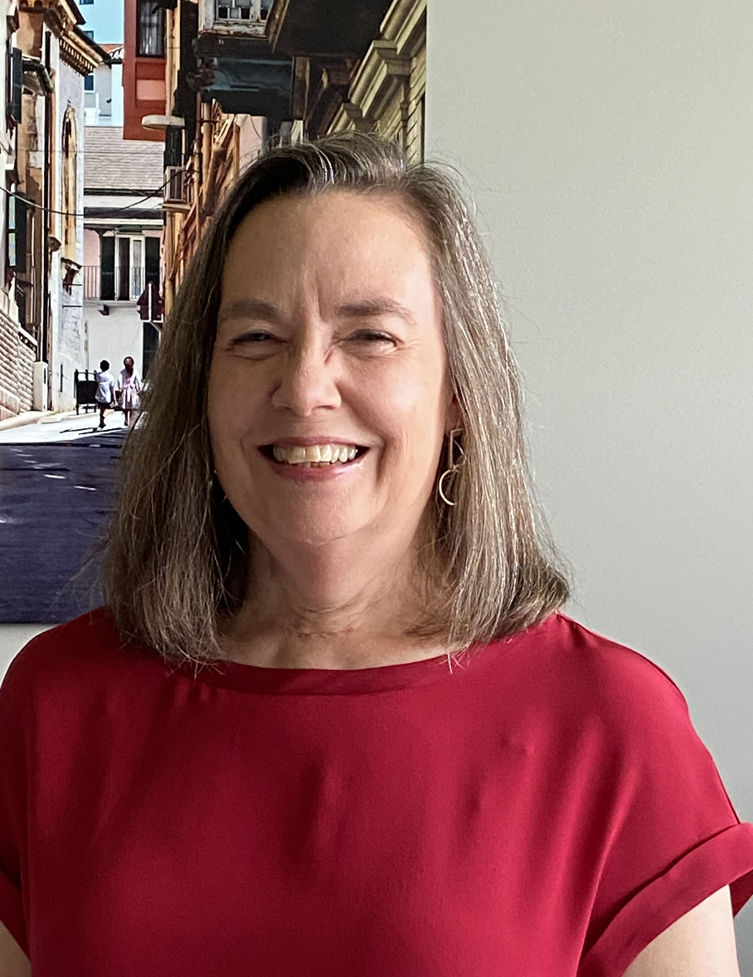
Lee-Ann H. Allen, PhD

Dr. Lee-Ann H. Allen obtained her PhD in Biochemistry from the University of Wisconsin-Madison before relocating to New York for postdoctoral training at The Rockefeller University. It was at Rockefeller that her focus shifted from lipid biochemistry to innate immunity, and she developed a life-long interest in macrophages and neutrophils as well as confocal microscopy. Dr. Allen was recruited to the University of Iowa by Dr. William Nauseef as one of the founding members of the Iowa Inflammation Program. In this highly collaborative environment, she established her independent career and extended her studies to include manipulation of phagocytes by the bacterial pathogens Helicobacter pylori and Francisella tularensis. She rose through the ranks in affiliation with the Department of Internal Medicine, Division of Infectious Diseases and the Department of Microbiology (now the Department of Microbiology and Immunology) and in 2018 was named as the Kate Daum Professor. Research in the Allen lab has been continuously funded by the VA, NIH and other sources since 1999, and one of her greatest pleasures has been the opportunity to train and mentor the next generation of scientists. In keeping with this, she was co-PI of NIAID-funded T32 training grants for Postdoctoral Training in Immunology (2019-2020) and Research Training in Infectious Diseases (2015-2020). After 24 years at Iowa, Dr. Allen moved to the University of Missouri in 2020 to begin a new role as Professor and Chair of the Department of Molecular Microbiology and Immunology and the George Trimble Endowed Chair for Excellence in Medicine.

Dr. Allen’s leadership activities include being an Associate Director of the NIAID Midwest Regional Center for Excellence for Biodefense and Emerging Infectious Diseases Research (2007-2014), Chair of the Phagocytes Gordon Research Conference (2013), and service on several grant review panels and editorial boards, including JLB. At the University of Iowa, she was a member of Executive Committees for the Medical Scientist Training Program (2011-2020), the Interdisciplinary Graduate Training Program in Immunology (2016-2020) and the Department of Microbiology and Immunology (2020) and served as Associate Director of the Center for Immunology and Immune-Based Diseases (2016-2020).

Her longstanding affiliation with SLB began as a junior faculty member, and in addition to her on-going role on the JLB Editorial Board she has been a member of the Nominating Committee (2003-2005) and served two terms as Treasurer (2009-2012) before being elected as President (2018-2019). Currently, Dr. Allen represents SLB as a member of the FASEB Board of Directors (2019-2027) and in conjunction with this, chairs the SLB Public Affairs Committee.

In recognition of her accomplishments, Dr. Allen was elected as a Fellow of the American Academy of Microbiology in 2018 and as a Fellow of the American Association for the Advancement of Science in 2021. In 2023-2024 she was a Fellow in the Hedwig van Ameringen Executive Leadership in Academic Medicine (ELAM®) program that is affiliated with Drexel University in Philadelphia.

